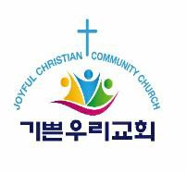

2023 JCCC Scholarship Award Timeline

Date | Schedule
April 10, 2023 | Announcement of scholarship application
May 31, 2023 | Application deadline
Week of August 1, 2023 | Announcement of scholarship award recipients
Late August 2023 | A scholarship award ceremony will be held during worship service at JCCC. The exact date will be posted on the JCCC website, www.joyfulccc.org.

